
STCAT SEND Provision Map
Overview – Four Areas of Need

STCAT Provision Map Overview – Four Areas of Need
DATE: November 2024 | AUTHOR: Michelle Chappell – STCAT Strategic Leader Inclusion

SEND Code of Practice – Four Areas of Need
The table below outlines how every school in the St Thomas Catholic Academies Trust (STCAT) identifies, assesses, supports and reviews children with Special Educational Needs and Difficulties (SEND) in line with the SEND code of Practice’s Assess / Plan / Do / Review cycle.

Please note that referrals to external agencies are completed based on an individual child’s needs, in line with the graduated response. A referral does not guarantee that the child will be assessed by the external agency in a timely manner and may not be possible based on the availability of resources.
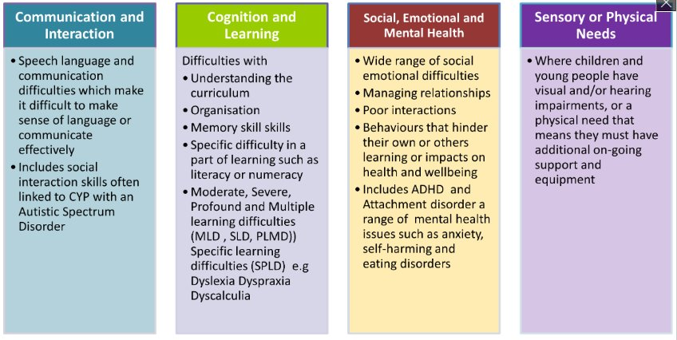

Communication and Interaction | Cognition and Learning | Social, Emotional and Mental Health | Sensory or Physical Needs
Examples  - Speech, language and communication needs (SLCN)  - ASD – Autism Spectrum Disorder, Aspergers’ Syndrome | Examples  - MLD – moderate learning difficulties  - SLD – severe learning difficulties  - PMLD – profound multiple learning difficulties  - SpLD - Specific Learning Difficulties – dyslexia, dyscalculia, dyspraxia | Examples  - Mental Health difficulties – anxiety, depression, self-harming, substance misuse, eating disorders  - ADHD – Attention Deficit Hyperactive Disorder  - ADD – Attention Deficit Disorder  - Attachment Disorder | Examples  - VI – Vision Impairment  - HI – Hearing Impairment  - MSI – Multi-Sensory Impairment  - PD – Physical Disability
How we identify and assess  - Teacher observation and Feedback (stage one)  - Links with outside agencies – eg Paediatrician, Autism service if appropriate  - Speech and Language Assessments if appropriate  - EP Assessment / SEND Advisory Teachers (where available)  - CATs (Sec only) | How we identify and assess  - Teacher observation and Feedback  - EP Assessment (where available)  - NGRT  - NGST  - CATS (Sec only)  - CTOPP  - Progress Tests (En, MA, Sc)  - EXACT (Sec only)  - SATS  - RAPID screener | How we identify and assess  - Teacher observation and Feedback  - EP Assessment (where available)  - PASS  - Culture of noticing (safeguarding)  - CAMHs assessment (if appropriate) | How we identify and assess  - Teacher observation and Feedback  - Medical information and diagnosis (incl. Health Care Plans)  - Links with external agencies  - Physio and OT referrals (if appropriate)  - Sensory questionnaire
Interventions  - Speech and Language (where available / if appropriate)  - Bucket time / TEACCH activities  - Attention Autism  - Social Skills  - Social stories  - Sensory Room / Area in school  - Sensory Circuits | Interventions  - Phonics  - Guided reading  - Comprehension  - Spellings  - Touch typing  - Numeracy  - Precision teaching | Interventions  - Mentoring  - Counselling  - social skills  - life skills  - enrichment opportunities  - Safe place to attend for time out  - Regular check-ins  - Sensory Circuits | Interventions  - Sensory circuits  - fine motor skills – including handwriting  - Adapted PE equipment  - Specialist teacher (where available / if appropriate)  - OT*  - Physio therapy*  - Braille*  * where specified on EHCP / medical advice
Adaptive teaching may include…  - Given time to respond  - Adapted questioning  - Structured group activities with prompts  - Use of images to extend discussion  - Chunking information  - Repeating information  - Rest breaks  - Exam access arrangements (ET, Reader, Writer, Prompt, Rest breaks, separate exam room) | Adaptive teaching may include…  - Pre-teaching vocabulary  - Word banks  - Writing frames / scaffolds / sentence starters  - Key terms highlighted  - Use of images / visuals  - Enlarged text  - Prepare for questions / reading out loud  - WAGOLL  - Task plans  - Computer reader  - Word processor  - Coloured overlays / backgrounds  - Reduced information in written form  - Print information from IWB  - Chunking information  - Manipulatives available in Maths  - Exam access arrangements (ET, Reader, Writer, Prompt, Rest breaks, separate exam room) | Adaptive teaching may include…  - Building positive relationships  - Checklists  - Targeted feedback  - Positive use of responsibility  - Language of choice  - Use of praise for effort and outcomes  - Routines and consistent approaches  - Time out / rest breaks  - Exam access arrangements (ET, Reader, Writer, Prompt, Rest breaks, separate exam room) | Adaptive teaching may include…  - Enlarged resources  - Use of images and concrete resources  - Use of Braille*  - Hearing Loop / Radio Aids*  - Use of ipads  - Adjusted seating  - Environmental adjustments  - Leave lesson early / arrive late pass  - Reduced information in written form  - Print information from IWB  - Exam access arrangements (ET, Reader, Writer, Prompt, Rest breaks, separate exam room)  * where specified on EHCP / medical advice
How we review  - Observations  - Assessment  - Lesson drop-ins  - External agency involvement  - Speaking to child  - Meeting with parents / carers  - Attendance  - Achievement and behaviour points | How we review  - Observations  - Assessment  - Lesson drop-ins  - External agency involvement  - Speaking to child  - Meeting with parents / carers  - Attendance  - Achievement and behaviour points | How we review  - Observations  - Assessment  - Lesson drop-ins  - External agency involvement  - Speaking to child  - Meeting with parents / carers  - Attendance  - Achievement and behaviour points | How we review  - Observations  - Assessment  - Lesson drop-ins  - External agency involvement  - Speaking to child  - Meeting with parents / carers  - Attendance  - Achievement and behaviour points

Michelle Chappell
STCAT Strategic Leader Inclusion
November 2024

